Warm Calling Meeting
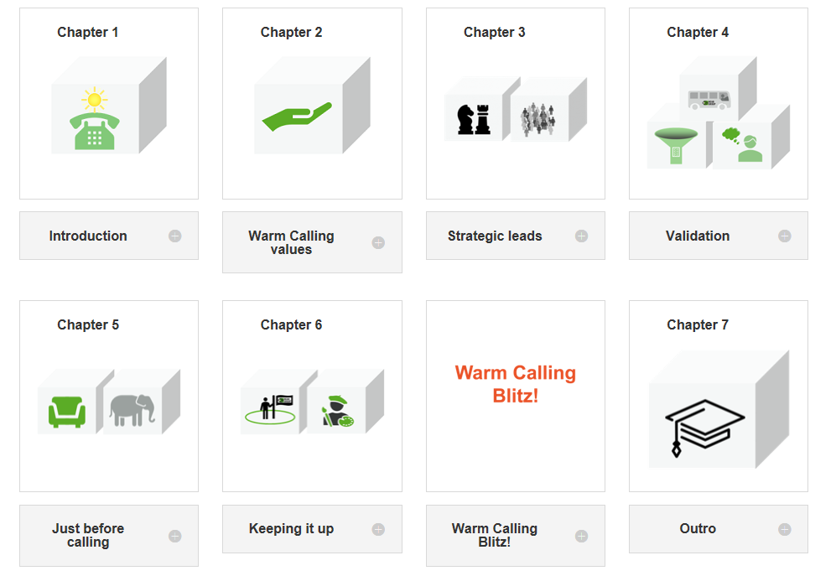
This meeting aims to follow up on the content and assignments from the Warm Calling course. It also prepares for a successful Warm Calling blitz.
Preparation
Complete the chapters and assignments in the Warm Calling course up to chapter 6. Bring your notes and material from the assignments.
Make sure that you as host do the preparations yourself – this will help you lead the meeting productively.
Agenda
- Welcome! We are here to follow up the Warm Calling course’s chapters and assignments [as preparation for the Warm Calling blitz next week].
- Everyone speaks in turn, 1-2 minutes each around the table, answering one question at a time. Different people start every new round of questions.
- Chapter 3: Strategic leads + assignment.
Which tools were most interesting and which ones did you use?
What are your conclusions – what could you do differently in the future?
- Complete Chapter 4: Validation + assignment. Person 2 please start.
Which tools did you use? Any surprising results?
What are your conclusions – what could you do differently in the future?
- Complete Chapter 6: Keeping it up + assignment. Person 3 please start.
Did you find any old leads that should get another chance?
What are your conclusions – what could you do differently in the future?
- Comments/questions
- Summary
- End meeting

