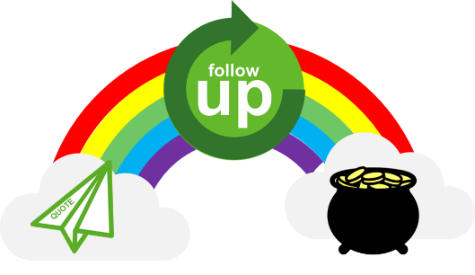
Quote follow up – open questions cheat sheet
Below are some questions to use for inspiration when doing quote follow-ups. Translate them into your local language, and/or add your own favorite questions in the lists.
Opening
- When is a good time for me to call you back?
- How are you doing with the project?
- Where are you now in the process?
- How did our offer meet your expectations?
- Your favorite question
- Your favorite question
- Your favorite question
Discussing the solution you’ve offered
- How interesting do you find our offer?
- What are you comparing to, and how do the other offer/s differ from our offer?
- What can I do to meet your expectations?
- What needs to happen for us to have the order?
- What do you need to succeed with your project?
- Your favorite question
- Your favorite question
- Your favorite question
Agreeing on a next step or closing the deal
- What can I do to help the project forward?
- How can I help you win your order/project?
- When do you plan on making a decision?
- When are you planning to release the order?
- What questions do you have for me?
- When is it convenient for you that I call you back?
- Your favorite question
- Your favorite question
- Your favorite question
If the project is lost.
- What can I do differently next time to meet your needs?
- When is a good time to discuss the next project?
- When is it convenient that I come visit you next time?
- Your favorite question
- Your favorite question
- Your favorite question

